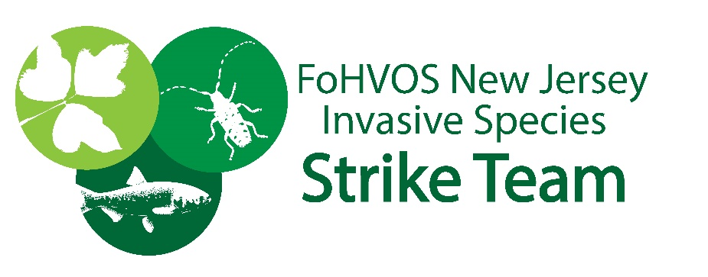

Landscape Planting Pledge

Invasive plants pose a serious threat to the natural heritage of the New Jersey. Unfortunately, many of these species can be purchased for landscape planting – some examples include Japanese Barberry, Chinese Silvergrass and Callery Pear. Through our special program, the New Jersey Invasive Species Strike Team, we maintain a “Do Not Plant List”. For additional information on invasive plants and gardening, please visit us.

In support of the Strike Team,
I pledge to avoid new purchases of any listed invasive plants.

Name
Street
Address
Town
State
Zip Code
E-Mail
Phone
Signature

Please return signed pledge to:
Michael Van Clef, Friends of Hopewell Valley Open Space, PO Box 395, Pennington, NJ 08534

